# Using ORACLE server 12c Answers and notes

**Lab 1 1 % Due September 21, 2017 midnight via BLearn**

Use your Oracle USER ID STxx on BTACS server database.

* Use the SQL Developer HELP (Tutorial: Creating Objects for a Small Database) to find the Script to create library objects. This small library schema has three tables: BOOKS, PATRONS, and TRANSACTIONS. Additionally, the script has a sequence, a view, a trigger, and a stored procedure.
* Run the script to create the database and to insert the data.

1. Use the following box and indicate the primary and foreign keys:

books ( book_id, title, author_last_name, author_first_name, rating)

patrons (patron_id, last_name, first_name, street_address, city_state_zip, location)

transactions (transaction_id, *patron_id*, *book_id*, transaction_date, transaction_type)

Please note the following codes: transaction code 1 = checking out , 2 = returning 3 = placing a hold

1. Create SQL statements to add
   1. Yourself as a patron
   2. Our textbook as a book (with high rating!)
   3. Transaction to take the book out from the library. Use today’s date and time as a transaction date and time.

INSERT INTO patrons

VALUES (patron_id_seq.nextval,'Mila','K','TRU', 'Kamloops, BC V2C0C8', null);

INSERT INTO books

VALUES ('DB111','Database Systems', 'Connoly Berg','Thomas', 10);

INSERT INTO transactions(transaction_id, patron_id, book_id, transaction_date, transaction_type)

VALUES (1001, 100, 'DB111', SYSDATE, 1);

*Please note the values for the transaction id and patron id could be different for each user (student).*

1. Prepare a select statement to list all patrons ordered by the last name (this list should include your name).

SELECT * FROM

PATRONS

ORDER BY last_name;

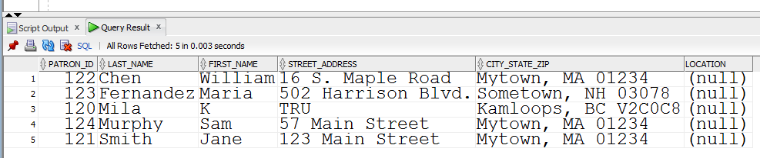

1. Write an SQL query to list all tables created by you (USER_TABLES). List the table names only.

SELECT TABLE_NAME

FROM USER_TABLES;

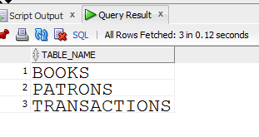

1. Write an SQL query to list all tables, sequences, and indexes created by you (USER_OBJECTS). List the names of the objects, types, and date and time of their creation.

SELECT OBJECT_NAME, CREATED, OBJECT_TYPE

FROM USER_OBJECTS;

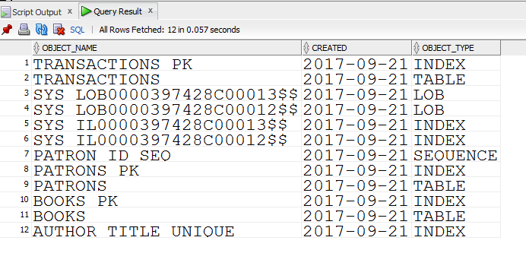

1. Write an SQL query to display current **date and time** using **ISO 8601 date/time standard with the local time zone.**
   1. Using the date/time from the Oracle server
   2. Using the date/time from the user session (client session using SQLDeveloper).

SELECT TO_CHAR(SYSDATE, 'YYYY-MM-DD HH24:MI:SS') FROM DUAL;

also

SELECT TO_CHAR(SYSDATE, 'YYYY-MM-DD"T"HH24:MI:SS') FROM DUAL;

TO_CHAR(SYSDATE,'YY

-------------------

2017-09-26T11:08:57

SELECT TO_CHAR(CURRENT_DATE, 'YYYY-MM-DD"T"HH24:MI:SS') FROM DUAL;

TO_CHAR(CURRENT_DAT

-------------------

2017-09-26T11:07:17

1. Write an SQL query to display the name of day spelled out in English (e.g., Monday, Tuesday,…) of your date of birth . You may use TO_CHAR () and TO_DATE () to convert between strings and date.

SELECT to_char(to_date('1977-10-09', 'YYYY-MM-DD'), 'Day')

FROM dual;

TO_CHAR(T

---------

Sunday

**Submit the answer as a pdf file**

1. List of the tables and their primary and foreign keys. (box above)

2. SQL queries and their results for questions 2-7.